Andre Hardy – Project 12-1

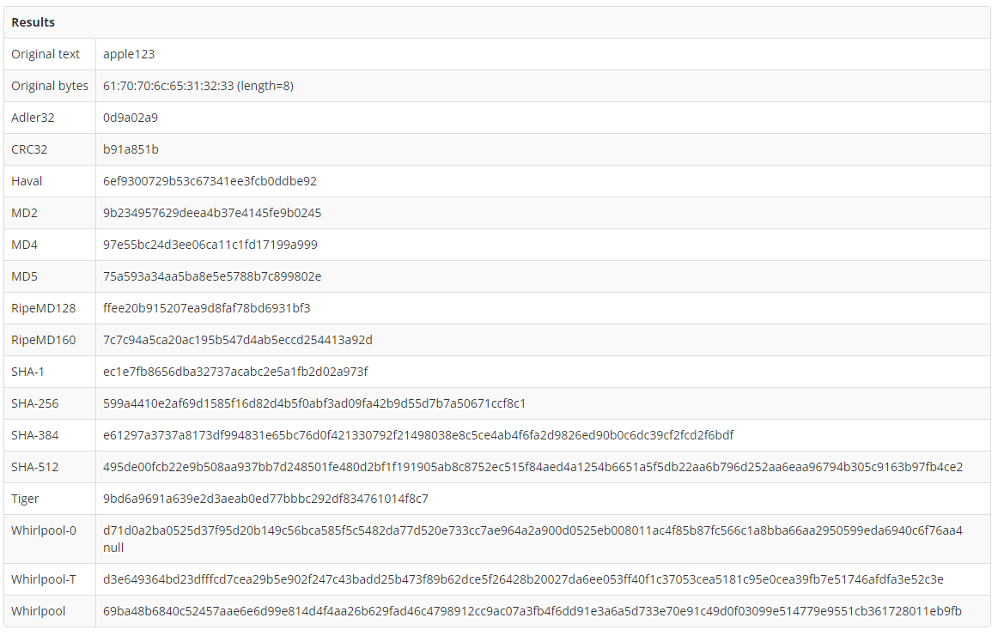

10. how long did it take to crack this hash?
A: It was cracked instantly
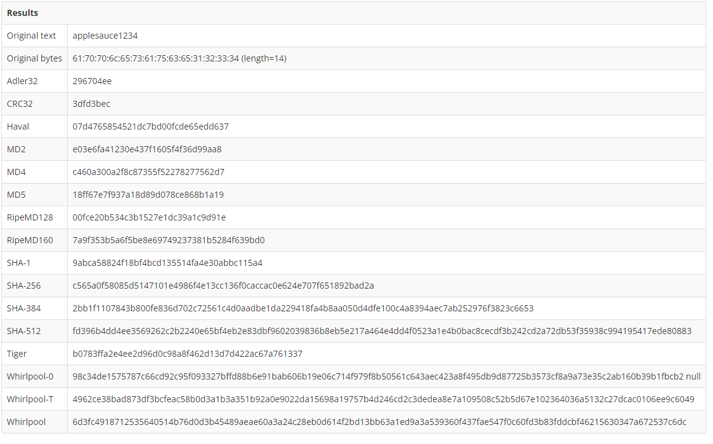

18. how long did it take this online rainbow table to crack the stronger password hash?
A: It took the same amount of time, which was no time at all

20. What does this tell you about the speed of password cracking tools? What does it tell you about how easy it is for attackers to crack weak passwords?
A: The speed of these free and available password tools are much faster than I knew, attackers are cracking easy passwords literally instantaneously

